USB Host and Device
The DE2 board provides both USB host and device interfaces using the Philips ISP1362 single-chip USB controller. The host and device controllers are compliant with the Universal Serial Bus Specification Rev. 2.0, supporting data transfer at full-speed (12 Mbit/s) and low-speed (1.5 Mbit/s). Figure 1 shows the schematic diagram of the USB circuitry; the pin assignments for the associated interface are listed in Table 1.
Detailed information for using the ISP1362 device is available in its datasheet and programming guide; both documents can be found in the ISP1362 references below. The most challenging part of a USB application is in the design of the software driver needed. Two complete examples of USB drivers, for both host and device applications, can be found in Sections 5.3 and 5.4. These demonstrations provide examples of software drivers for the Nios II processor.
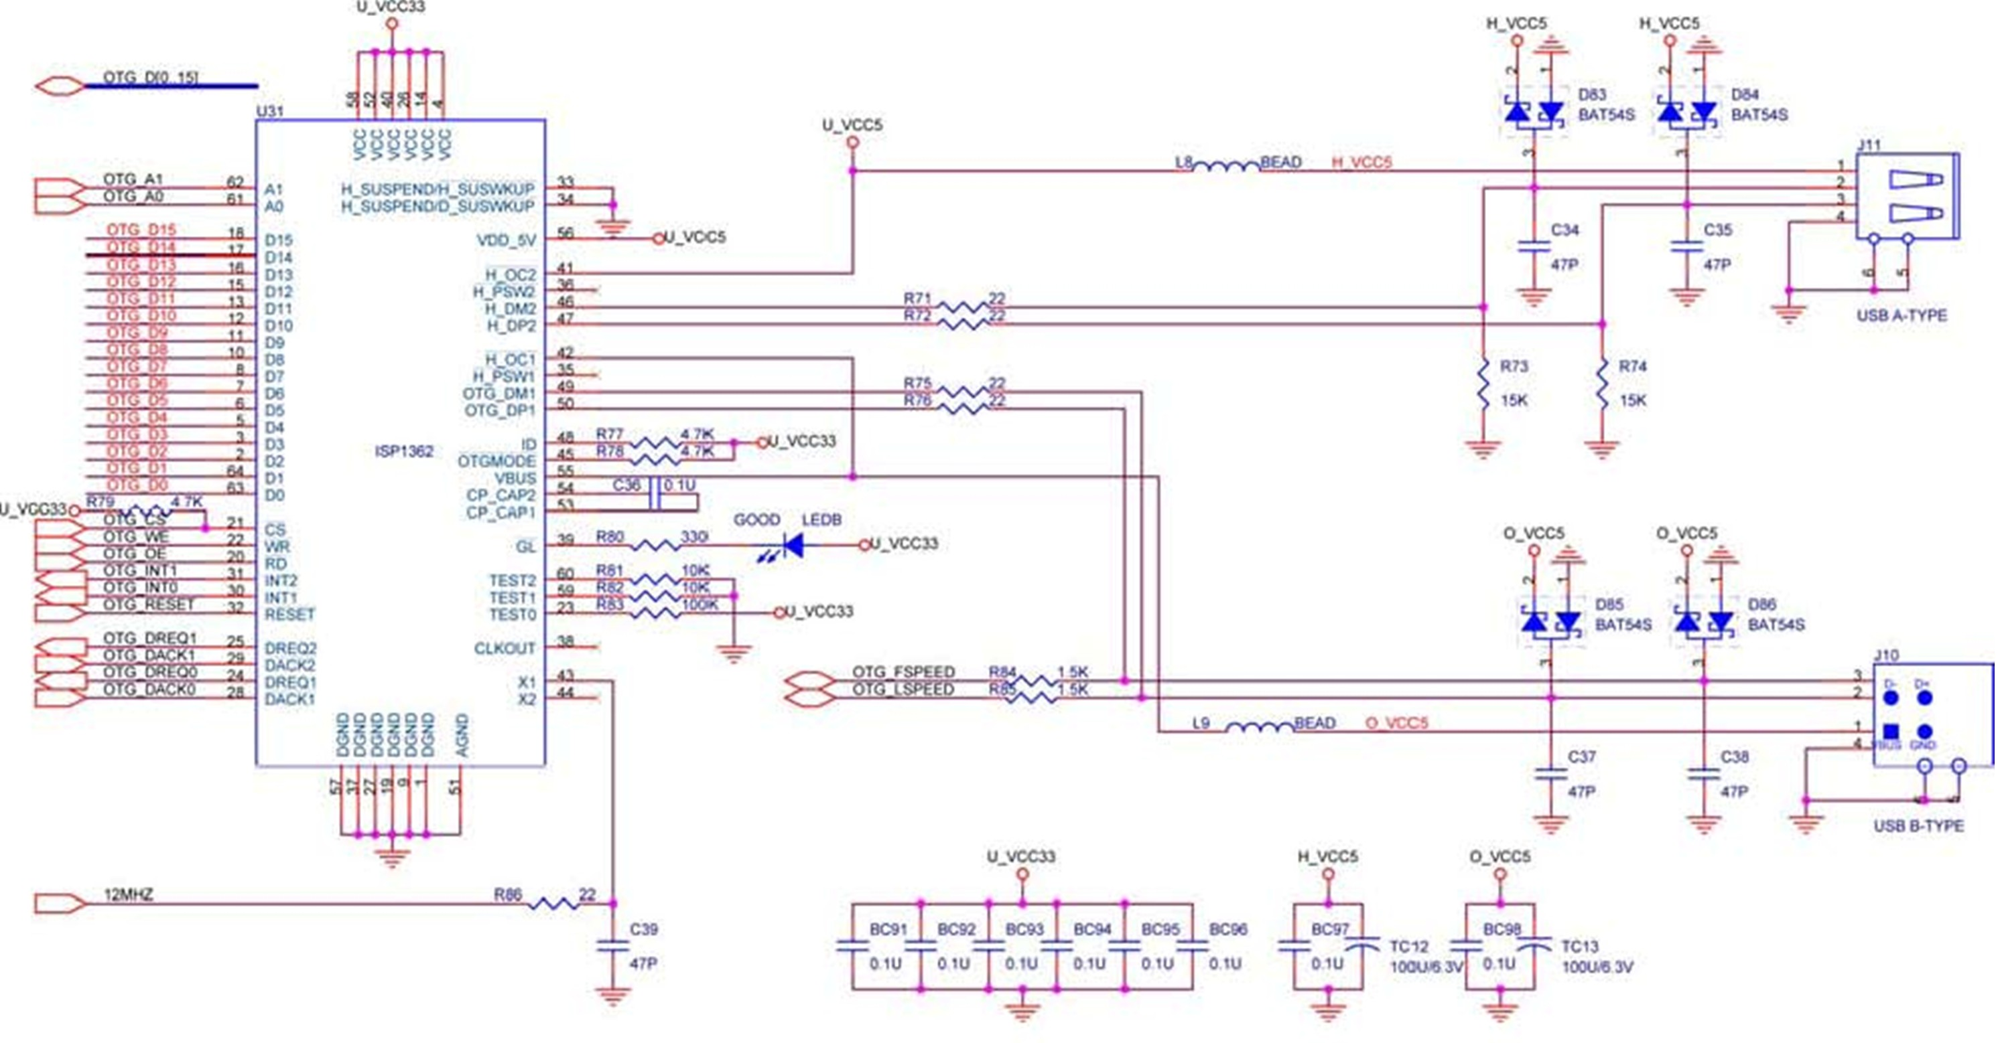
Figure 1. USB (ISP1362) host and device schematic.
Table 1. USB (ISP1362) signal assignments
Signal Name | Description
OTG_ADDR[1:0] | ISP1362 Address[1:0]
OTG_DATA[15:0] | ISP1362 Data[15:0]
OTG_CS_N | ISP1362 Chip Select
OTG_RD_N | ISP1362 Read
OTG_WR_N | ISP1362 Write
OTG_RST_N | ISP1362 Reset
OTG_INT0 | ISP1362 Interrupt 0
OTG_INT1 | ISP1362 Interrupt 1
OTG_DACK0_N | ISP1362 DMA Acknowledge 0
OTG_DACK1_N | ISP1362 DMA Acknowledge 1
OTG_DREQ0 | ISP1362 DMA Request 0
OTG_DREQ1 | ISP1362 DMA Request 1
OTG_FSPEED | USB Full Speed, 0 = Enable, Z = Disable
OTG_LSPEED | USB Low Speed, 0 = Enable, Z = Disable

